Case Study of Linux Operating System

# Evolution of Linux

The Linux operating system has its roots in the Unix operating system, which was developed in the late 1960s and early 1970s at AT&T's Bell Labs. Unix was revolutionary due to its portability, multi-user capability, and modular design.

**Early Days (1991-1992)**

Linux was created by Linus Torvalds, a Finnish student, as a hobby project. He announced his intentions to create a free operating system on the Usenet newsgroup in August 1991. The first version, Linux 0.01, was released in September 1991. The kernel was initially based on the GNU operating system, and the first release included a binary of GNU’s Bash shell. Initially, Torvalds created Linux as a personal project to leverage the power of Intel’s 80386 processor.

**GNU Project (1983)**

Richard Stallman, the founder of the GNU Project, had been working on a free operating system called GNU since 1983. The GNU Project aimed to create a free and open-source operating system, and Linux was designed to be a kernel for the GNU system.

**Linux 0.99 (1992)**

In December 1992, Linus Torvalds released Linux 0.99, which was the first version to be licensed under the GNU General Public License (GPL). This marked a significant milestone in the evolution of Linux, as it allowed the community to contribute to the development of the operating system.

**Rapid Growth (1993-1995)**

The mid-1990s saw rapid growth in the Linux community, with the release of Linux 1.0 in March 1994. This version included support for networking, file systems, and device drivers. The Linux kernel continued to evolve, with new features and improvements being added regularly.

**Commercial Support (1995-1999)**

In the late 1990s, commercial support for Linux began to emerge, with companies like Red Hat and Caldera offering Linux distributions and support services. This marked a significant shift in the evolution of Linux, as it brought the operating system into the mainstream.

# Different Variants of Linux

Linux has spawned numerous distributions, each tailored to different needs and preferences, known as "distros." Some of the most popular include:

**The Big Three**

- Arch Linux: Favoured by advanced users, Arch Linux offers a rolling release system and a minimalist, DIY approach, allowing users to build their systems from the ground up.

- Debian: One of the oldest distributions, Debian is known for its stability and extensive package repositories. It serves as the base for many other distributions, including Ubuntu.

- Fedora: Sponsored by Red Hat, Fedora is known for incorporating the latest technologies and innovations. It is often used by developers and system administrators.

**Other distros which are forks or derivatives of the above include:**

- Ubuntu: Known for its user-friendly interface and strong community support, Ubuntu is based on Debian and is widely used on desktops and servers.

- Linux Mint: An Ubuntu-based variant with a focus on ease of use and the Cinnamon desktop environment.

- CentOS: A free, community-supported alternative to Red Hat Enterprise Linux (RHEL), CentOS is widely used in enterprise environments for its reliability and performance.

- Zorin OS: A user-friendly distro that offers a Windows-like interface and is designed to help users transition from Windows to Linux.

- Pop!_OS: A distro designed for gamers and content creators, with a focus on ease of use and a modern interface.

- Kali Linux: A distro designed for penetration testing and digital forensics, with a focus on security and a wide range of tools.

- Red Hat Enterprise Linux (RHEL): A commercial-grade distro designed for enterprise use, with a focus on stability and security.

- SUSE Linux: a Linux distro split into openSUSE and SUSE Linux Enterprise.

Each variant of Linux caters to different user requirements, from beginner-friendly environments to highly customizable systems for experienced users.

# Architectural Layout of Linux

The architectural layout of the Linux operating system is based on a monolithic kernel design, meaning the core of the OS, the kernel, manages all system resources and operations. The key components include:

**Hardware Layer:** The lowest level of the Linux architecture is the hardware layer, which comprises the physical components of a computer, such as the hard drive, RAM, motherboard, CPU, network interfaces, and peripherals. These components are the tangible pieces of your system on which the rest of the architecture is built.

**Kernel Layer:** The kernel layer is the second level of the Linux architecture. It is responsible for managing the hardware resources and providing services to the higher-level layers. The kernel is the core of the operating system and is responsible for tasks such as process scheduling, memory management, and input/output operations.

**Shell Layer:** The shell layer is the third level of the Linux architecture. It is responsible for providing a command-line interface to the user and for executing commands and programs. The shell is a program that runs on top of the kernel and provides a way for the user to interact with the operating system.

**Application Layer:** The application layer is the topmost level of the Linux architecture. It consists of the software programs that you, as the user, interact with directly. These programs range from system applications like file managers, text editors, and network managers, to user applications like browsers.

**Connections between Layers:** The layers of the Linux architecture are connected in a hierarchical manner, with each layer building upon the services provided by the layer below it. The hardware layer provides the foundation for the kernel, which in turn provides services to the shell, which ultimately provides an interface to the user through the application layer.

This architecture ensures high performance, security, and modularity, making Linux suitable for a wide range of applications.

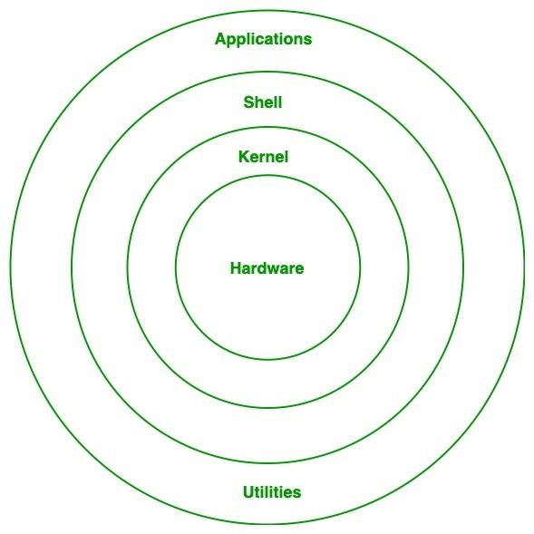

# Founders of Linux/Unix

The Unix operating system, which laid the groundwork for Linux, was created by **Ken Thompson, Dennis Ritchie, and others** at AT&T's Bell Labs in 1969. Thompson developed the initial version of Unix on a PDP-7 minicomputer, and Ritchie contributed by creating the C programming language, which became essential for developing Unix.

**Linus Torvalds** is the principal founder of Linux. In 1991, as a student at the University of Helsinki, Torvalds began developing the Linux kernel as a personal project. Inspired by the MINIX operating system, Torvalds aimed to create a free, open-source alternative. He released the first version of the Linux kernel (version 0.01) in September 1991, inviting contributions and modifications from other developers worldwide.

**Richard Stallman**, founder of the Free Software Foundation, also played a crucial role by creating the GNU Project in 1983, which aimed to develop a free Unix-like operating system. The combination of the GNU software components and the Linux kernel resulted in a fully functional and free operating system, commonly referred to as GNU/Linux.